PRESS RELEASE NO 4 FOR LUDLOW ADVERTISER



LUDLOW ROTARY TREE OF LIGHT SUPPORTS LOCAL COMMUNITY

Each Christmas, the Ludlow Rotary Tree of Light gives local residents the opportunity to shine a light in memory of a loved one, to celebrate a special occasion, or to send good wishes to friends or family by making a dedication and donation.

This year the Tree of Light, which will remain lit until Twelfth Night on 6 January, has already raised over £600 in donations. The list of dedications received in time for inclusion in the Christmas edition of the Ludlow Advertiser [is enclosed] and will be repeated on the Ludlow Rotary website.

On behalf of Ludlow Rotary, Barry Forrester said “We are grateful to all who have supported the Tree of Light this year with their dedications and donations. Our thanks also go to Ludlow Town Council for installing the light display on the tree, Ludlow Choral Society for leading the carol singing when they were switched on, Nock Deighton for acting as a collecting point and the Ludlow Advertiser for its press coverage.”

He added “It is not too late to make a donation and dedication via our website www.ludlowrotaryclub.org.uk where we will be publishing the final list of dedications received by Twelth Night. The full amount raised will be earmarked for our community grants scheme, Ludlow Rotary Cares, taking place in Spring 2026.”

Notes for Editors

1. This photo of the Tree of Light (jpeg attached) may be used as required.

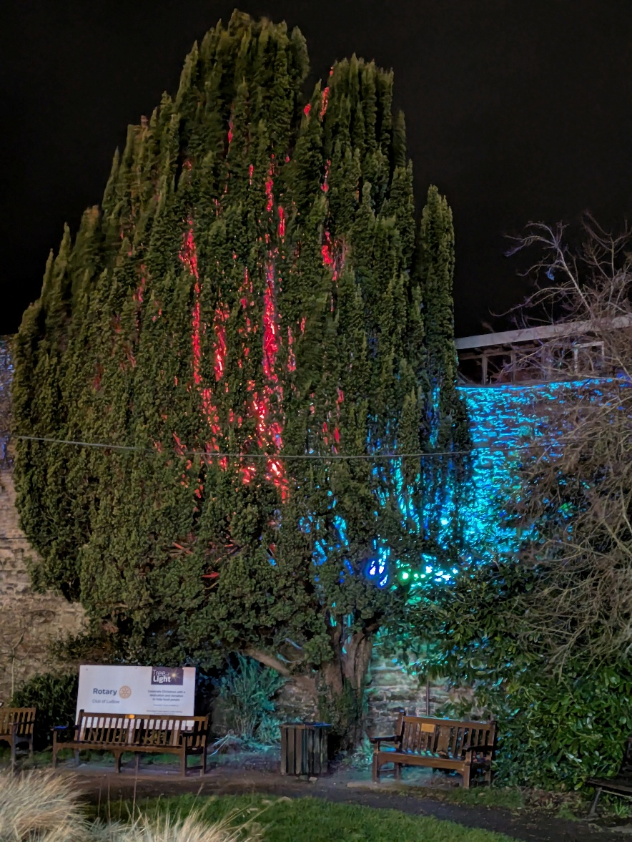

2. For further information contact:

Barry Forrester
forrester.ludlow@gmail.com
01584 878872 / 07786 078470

