

PRESS RELEASE

LUDLOW ROTARY SEEKS YOUNG LEADERS OF TOMORROW

Ludlow Rotary Club wants to hear from young people aged 16 or 17 who would like to be considered for this year’s Rotary Youth Leadership Award scheme – RYLA for short.

Each year the club aims to sponsor one or two youngsters who might benefit from what is regarded as one of the most successful youth schemes run by Rotary. It offers a fun yet intensive training programme for young people, both boys and girls, aimed at nurturing and encouraging leadership and communication skills and giving participants a head start at an early age.

Over the course of the five-day residential camp held at Boreatton Park, Baschurch in north Shropshire, activities are arranged which encourage initiative and organisational skills and which help participants to develop confidence and creative problem-solving methods. The youngsters work in teams and are supervised at all times by trained and qualified instructors. In line with the Duke of Edinburgh award scheme, outdoor activities are a crucial part of the experience. Debates and discussion are also encouraged.

In sponsoring the youngsters, Ludlow Rotary Club meets all fees and transports the candidates to and from the venue.

Kim Olyett, who co-ordinates the club’s involvement in the programme, explained that the club’s interest in the youngsters does not end there: “Each year, after their return, the participants, together with their parents, are invited to a Rotary meeting to tell us about their experiences. Invariably it is enthusiastic. Over the years we have never failed to be impressed by how much the youngsters themselves recognise the positive impact and value that the programme has on their outlook as they prepare their CVs in support of their future educational and career choices”.

Kim added “I would be delighted to hear from potential applicants or their parents preferably by the end of February and would be happy to provide further information and an application form. The only stipulation is that applicants must be over 16 and under 18 when the programme takes place from 2 to 7 August 2026. I can be contacted at youthservices@ludlowrotaryclub.org.uk.”

Notes for Editors
1. The following photos, jpegs attached, which have been taken from past RYLA schemes, may be used with this article.
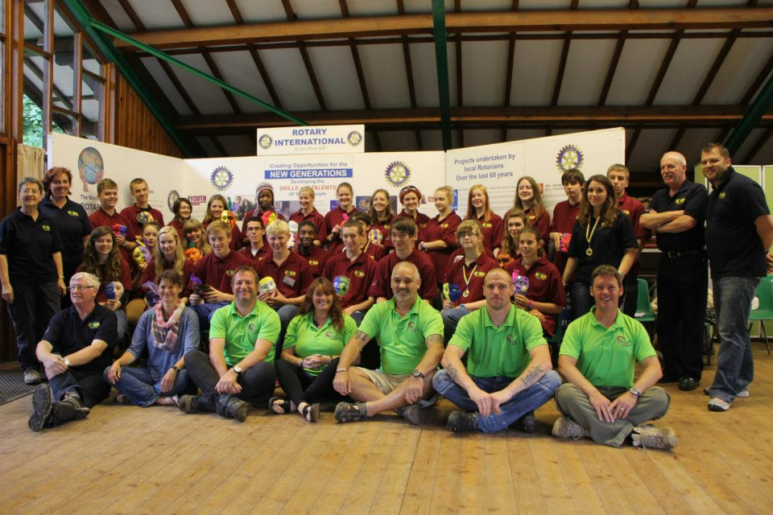
 | 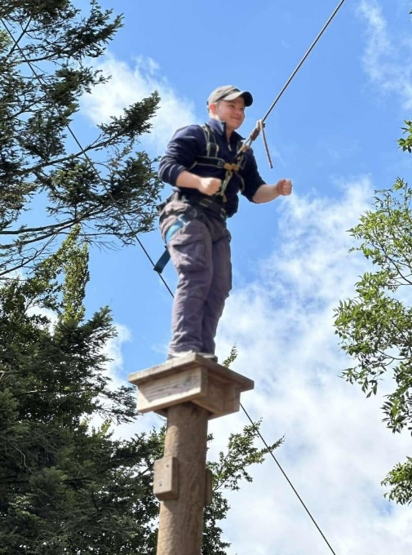

2. For further information please contact: Barry Forrester at forrester.ludlow@gmail.com or 01584 878872 / 07786 078470.

