PRESS RELEASE NO 3 FOR LUDLOW ADVERTISER



LUDLOW TREE OF LIGHT SHINES FOR THE TOWN

The Ludlow Rotary Tree of Light in Castle Gardens was formally switched on by the Mayor of Ludlow, Councillor Diane Lyle, last Friday (28 November). As she did so, Cllr Lyle took the opportunity to pay tribute to the work of Ludlow Rotary in championing community life and raising funds for local organisations for almost 90 years.

A selection of carols performed by the Ludlow Choral Society added a festive element to the evening.

Surrounded by strings of white lights with the tree itself lit in subtly changing colours, the whole area becomes a worthy focus for those remembering a loved one, marking a special occasion or expressing good wishes for friends or family this Christmas.

The Tree of Light will remain lit until Twelfth Night on 6 January and it is not too late to add a dedication. All those received by 14 December will be published in the Christmas edition of the Ludlow Advertiser. A complete list of dedications received by Twelfth Night will be recorded on the Ludlow Rotary Club website.
Forms containing full information on how to submit a dedication may be obtained from St Laurence’s Parish Church, Nock Deighton Estate Agents or downloaded from www.ludlowrotaryclub.org.uk. A minimum donation of £5 per dedication is invited with all funds received earmarked by Ludlow Rotary Club for local community projects. Last year some £800 was raised through the Tree of Light.

Notes for Editors

- These photos, JPEGS attached, may be used with the text. They should be credited to Ludlow Town Council

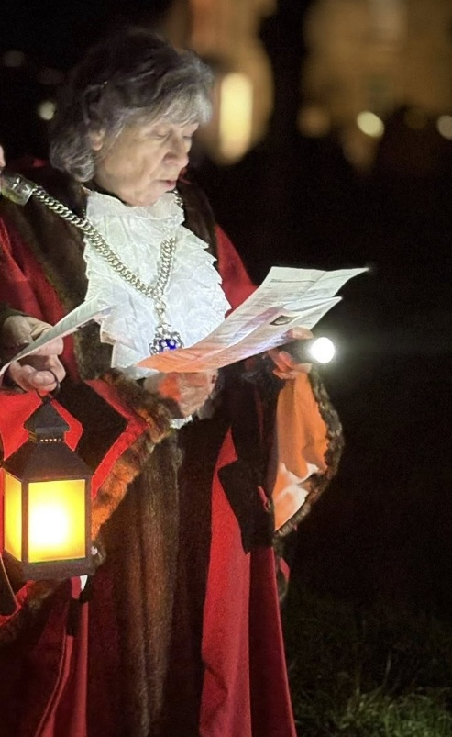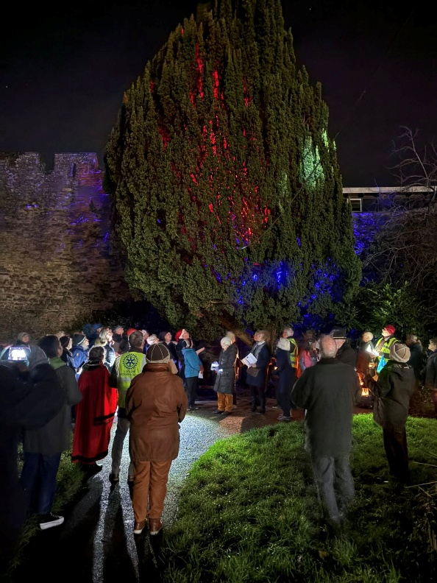

2. For further information contact:
Barry Forrester
forrester.ludlow@gmail.com
01584 878872 / 07786 078470

