PRESS RELEASE NO 2 FOR LUDLOW ADVERTISER



TREE OF LIGHT SUPPORTS COMMUNITY LIFE

Each year, the Tree of Light arranged by the Ludlow Rotary Club gives local residents the opportunity to shine a light in memory of a loved one, to celebrate a special occasion or to send good wishes to friends or family by making a dedication and donation. All funds raised are earmarked by Ludlow Rotary Club for local projects through its annual community grants scheme, Ludlow Rotary Cares.

Last year’s Tree of Light, along with other fundraising events organised by the club, made it possible for grants totalling £8,000 to be made to 13 community projects during 2025.

Nine of the grants were to organisations involved with children and young people. These included Ludlow Amateur Boxing Club who needed to update their specialist training equipment, the 1st Ludlow Scout Group who wished to improve the facilities available to their 60 members, and Ludlow Youth Club who wanted to buy some sports games equipment to promote physical activity.

Not that other community groups were overlooked. The Gallows Bank Millenium Green Trust which cares for a valued green space in the town, Read Easy Shropshire Hills which assists with adult literacy, the Ludlow & Area Community Partnership support scheme for sufferers of dementia and the Leintwardine Social Group which exists to combat loneliness amongst older people were also awarded grants.

This year, the Tree of Light in Castle Gardens will be switched on at 7pm on Friday 28 November by the Mayor of Ludlow, Councillor Diane Lyle. It will be preceded by a torch light procession through the Market Square beginning at 6.45pm led by the Ludlow Choral Society.

The tree will remain lit until Twelfth Night on 6 January.

Forms containing full information on how to submit a dedication may be obtained from St Laurence’s Parish Church, Nock Deighton Estate Agents or downloaded from www.ludlowrotaryclub.org.uk.

All dedications received by 14 December will be published in the Christmas edition of the Ludlow Advertiser. A complete list of dedications received by Twelfth Night will be recorded on the Ludlow Rotary Club website.

Notes for Editors

1. This photo may be used with the text. Parental approval for the use of the photo has been obtained.

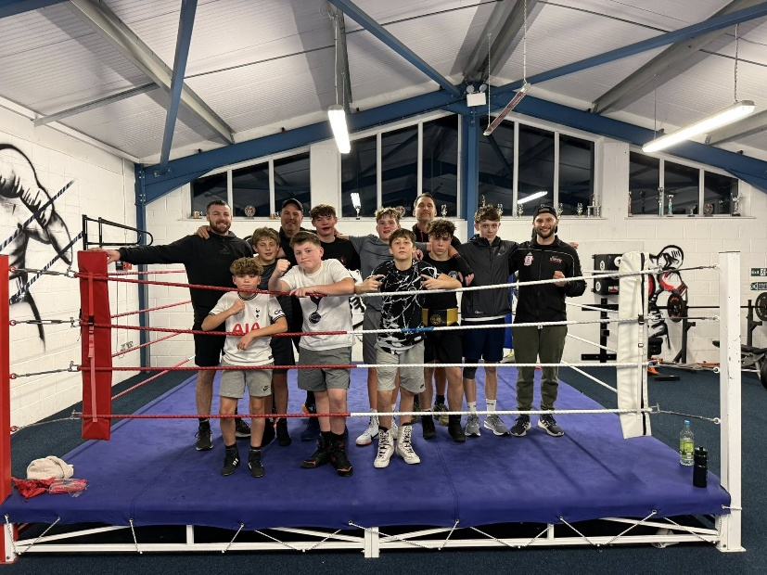
Some of the junior members of Ludlow Amateur
Boxing Club, one of the beneficiaries of a Rotary
grant in 2025

2. A full list of charities and community organisations benefitting from this year’s Ludlow Rotary Cares community grants scheme comprises:

- 1st Ludlow Scout Group
- Empathy for Special Children
- Gallows Bank Millenium Green Trust
- Kimbolton St James’ Primary School
- Lacon Childe School PTA
- Ludlow & Area Community Partnership – Dementia Support Group
- Ludlow & Area Community Partnership – Autistic Children Support
- Ludlow Amateur Boxing Club
- South Shropshire Engineering Ambassadors
- Shropshire Youth Association – Ludlow Youth Club
- Cleobury Mortimer Tiny Tots Playgroup
- Read Easy Shropshire Hills
- Leintwardine Social Group

3. For further information contact:
Barry Forrester
forrester.ludlow@gmail.com
01584 878872 / 07786 078470

