PRESS RELEASE  CLEE HILL SCHOOL JOINS LUDLOW ROTARY IN BATTLE TO END POLIO | 

On 12 November pupils from Clee Hill Community Academy braved misty weather to play their part in highlighting efforts to eradicate polio from the world. They helped members of Ludlow Rotary Club to plant over 4000 crocus corms in the school grounds. When they flower in February next year, they will bring a splash of purple and a reminder of this terrible disease that can kill or seriously disable children.

The purple crocus has long been a symbol of Rotary’s worldwide campaign to bring polio to an end, with its colour representing the dye used to mark the finger of a child who has been immunized.

For 40 years Rotary International has been battling to eradicate polio from the world. When it launched its global campaign to fight the crippling and sometimes deadly disease, more than 350,000 children were being paralyzed by polio every year in 125 countries. Today, as a result of an intensive immunization programme, the incidence of polio has been reduced by 99.9% and the wild polio virus is now only endemic in Pakistan and Afghanistan where just 35 confirmed cases have been identified so far this year. Rotary International, along with other agencies, continues to raise funds to bring this devastating and crippling disease to a world-wide end.

Speaking about this initiative, Ludlow Rotary organiser Tom Hunt said “It’s particularly fitting that Clee Hill School has been helping us in this way. For until polio is totally eradicated, every child is at risk of this highly infectious, potentially life-threatening and paralysing disease. There is no cure for polio but there is a safe and effective vaccine which we need to continue to roll out until there are no more cases. When the world is finally declared polio free, it will be just the second human disease ever to be eradicated, after smallpox.”

For more information about Ludlow Rotary Club and its work, contact secretary@ludlowrotaryclub.org.uk.

NOTES FOR EDITORS

Photo - The following photos, jpegs attached, may be used with this release. Parental permission to use the photos has been obtained.

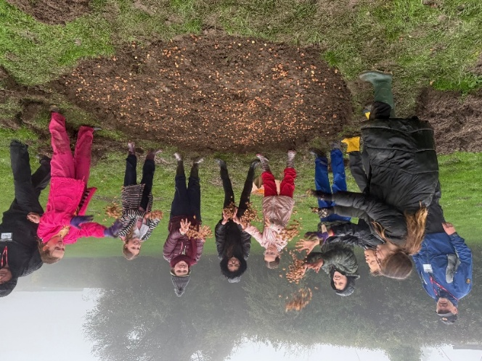 | 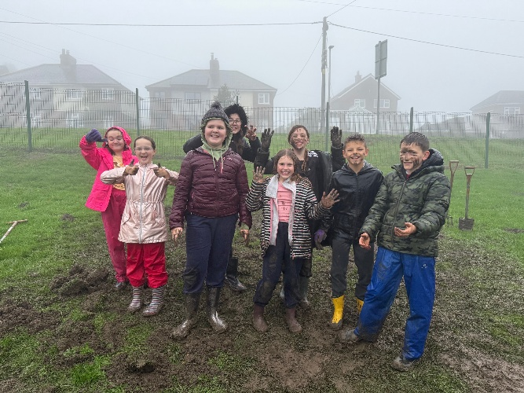
Pupils from Clee Hill Community Academy celebrating the end of the mucky
task of crocus corn plating

More about polio - Polio is the world’s forgotten disease and something that should have been made history a long time ago.

Some 40 years ago, Rotary spearheaded the campaign to bring it to an end at a time when there were over 1,000 polio cases a day in 125 countries, paralysing and killing children. Today, the number of cases is down by 99.9%.

Inspired in part by Rotary’s volunteer commitment and fundraising success, the Global Polio Eradication Initiative (GPEI) was launched in 1988. This remarkable partnership includes Rotary, World Health Organization, UNICEF, the US Center for Disease Control & Prevention and, more recently, the Bill & Melinda Gates Foundation and GAVI the Vaccine Alliance. These organisations work alongside governments of the world to end polio.

Because of the efforts of Rotary and its partners, nearly 19 million people who would otherwise have been paralysed are walking, and more than 1.5 million people are alive who would otherwise have died.

Despite there only being a very small number of confirmed cases left in the world, continued campaigning, health worker training and vaccination programmes are essential to stop the disease returning and ensuring the world is certified polio-free. Over 400 million children still have to receive their polio vaccinations by the GPEI partners multiple times every single year in more than 50 countries.

Failure to eradicate polio could result in as many as 200,000 new cases worldwide every year within a decade.

Rotary members continue to be key players in many aspects of the polio programme including on the ground in a number of countries as well as fundraising and advocacy.

For further information - Please contact Barry Forrester on 01584 878872 / 07786 078470 or at forrester.ludlow@gmail.com

