PRESS RELEASE FOR LOCAL MAGAZINES
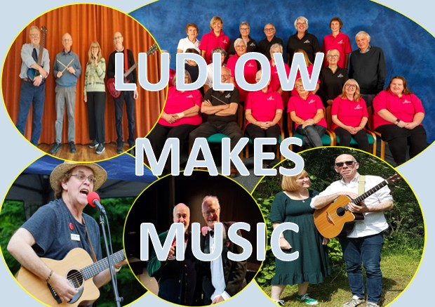 | 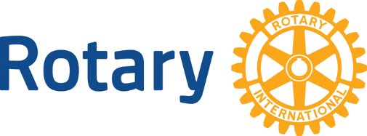
LUDLOW MAKES MUSIC
Ludlow has a reputation as the home of numerous musicians. An evening at St Laurence’s Church, Ludlow has been arranged by Ludlow Rotary when five local acts will showcase their talent to raise funds in support of local charities and community groups.
The variety show will comprise performances by:

- Kim & Martin Olyett – folk singers
- Julian Mount – songwriter, singer, and musician
- Kim Begley & David Gaukroger – Flanders & Swann classics
- Rockspring Community Choir
- Rockfall - rock & roll band

The evening is being held in support of ‘Ludlow Rotary Cares’, the club’s annual community grants scheme. Over the past 11 years Ludlow Rotary has been able to make grants totalling £60,000 to around 110 local community projects through this scheme.
The club is therefore hugely grateful that these local artists will be giving their time and talent completely free of charge. With associated costs being met through generous sponsorship, it means that every penny raised will help ensure that the scheme goes ahead again in the year ahead.
The concert takes place on 5 September and will begin at 7pm. Tickets are available from the Ludlow Assembly Rooms website: www.ludlowassemblyrooms.co.uk.

Barry Forrester
19 July 2025

NOTES FOR EDITORS
1. About Ludlow Rotary Cares
‘Ludlow Rotary Cares’ is the name of Ludlow Rotary Club’s annual scheme aimed at supporting community life in and around Ludlow by offering modest grants to local charities and organisations. The maximum grant available is now £750.

2. Photos
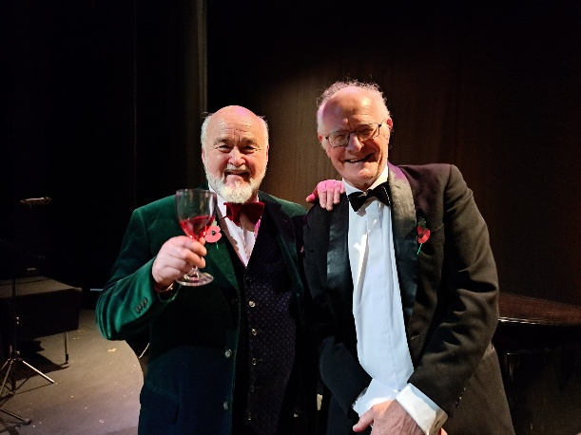

Kim Begley & David Gaukroger – Two of the performers on 5 September

This photo and those of the other performers are available as jpgs on request.
3. For Further information
Contact: Barry Forrester at forrester.ludlow@gmail.com or 01584 878872 / 07786 078470

