PRESS RELEASE
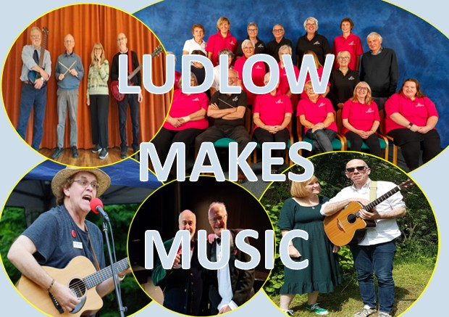 | 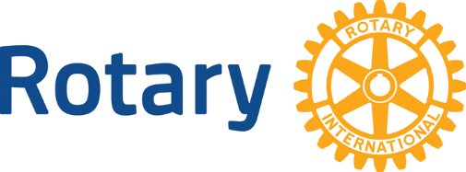
LUDLOW MAKES MUSIC
Ludlow has a reputation as the home of numerous musicians. An evening at St Laurence’s Church, Ludlow has been arranged by Ludlow Rotary when five local acts will showcase their talent to raise funds in support of local charities and community groups.
The variety show will comprise performances by:

- Kim & Martin Olyett – folk singers
- Kim Begley & David Gaukrogers – Flanders & Swan classics
- Rockfall - rock & roll band
- Rockspring Community Choir
- Julian Mount – songwriter, singer, and musician

Event organiser Tom Hunt said “We are holding this evening in support of ‘Ludlow Rotary Cares’, our annual community grants scheme.
“Over the past 11 years Ludlow Rotary has been able to make grants totalling £60,000 to around 110 local community projects through this scheme. Naturally we want it to continue.
“We are therefore hugely grateful that these local artists will be giving their time and talent completely free of charge. With associated costs being met through generous sponsorship, if means that every penny we raise will help ensure that the scheme goes ahead again in the year ahead.”
The concert takes place on 5 September and will begin at 7pm. Tickets are available from the Ludlow Assembly Rooms website: www.ludlowassemblyrooms.co.uk.

NOTES FOR EDITORS
1. About Ludlow Rotary Cares
‘Ludlow Rotary Cares’ is the name of Ludlow Rotary Club’s annual scheme aimed at supporting community life in and around Ludlow by offering modest grants to local charities and organisations. The maximum grant available is now £750.

2. Photos
A jpg of the event logo is attached.
Photos of each of the performers are available on request.
3. For Further information
Contact: Barry Forrester at forrester.ludlow@gmail.com or 01584 878872 / 07786 078470

